
This course also received the Exemplary Online Award in the category of Large Enrollment Strategies
This course received the highest Quality Online Course Designation (Exemplary Course) by the Center of Teaching Excellence.

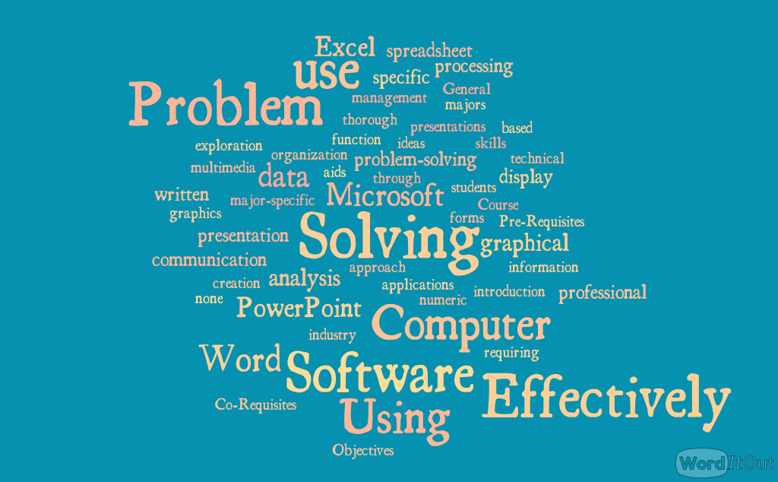
CGS2531 Problem Solving Using Computer Software
Sections 10672, 10673: Spring 2026
In light of the Student Learning Outcomes defined for different programs by the Warrington College of Business, these are the course goals for CGS2531.
You will use Excel, Word, and PowerPoint to aid your problem-solving process.
You will write a plan on how they would address an open-ended problem using the language of the problem-solving framework.
You will analyze real-world data, such as applying business statistics techniques and mathematical models and, create data visualizations for problem-solving.
You will demonstrate professional and inclusive communication.
Remember:
You will use these course goals in the final assignment.

Summary of what the students reported as their learning from a previous course
Microsoft Excel:
- Proficiency in using Excel for data management, analysis, and visualization.
- Skills in creating charts, using formulas, and performing regression analysis.
- Understanding of advanced Excel functions like cell referencing and the Analysis ToolPak.
Microsoft Word:
- Enhanced capabilities in document organization and formatting.
- Skills in creating professional documents, including the use of headers, footers, and tables of contents.
Microsoft PowerPoint:
- Improved skills in creating and designing professional presentations.
- Knowledge of advanced features like slide master and professional slide design.
Problem-Solving Process:
- Application of a structured problem-solving framework to real-world scenarios.
- Development of critical thinking and analytical skills.
Professional Communication:
- Improved ability to communicate professionally through written documents and presentations.
- Skills in crafting clear and effective communication for various professional contexts.

Course Description
(Credits: 3) A problem-solving introduction and thorough exploration of word processing, spreadsheet management, data analysis, graphical display of data, and multimedia presentations. The problem-solving approach also aids students in their specific majors through software applications requiring major-specific professional communication skills in written, graphical, and presentation forms. (M)
Primary General Education Designation: Mathematics (M) (Area objectives available here)
Note: A minimum grade of C is required for general education credit

Pre-Requisites & Co-Requisites
none

Student Learning Outcomes
In this course, you will be introduced to the following Student Learning Outcomes (SLOs) as required by the academic learning compact in the programs at the Heavener School of Business:

Content
- Demonstrate knowledge and understanding basic economics, financial accounting, marketing, operations management, organizational behavior, business law, information technology, business statistics, and social responsibility.
- Demonstrate proficiency in the use of business-related software applications

Similarly, this course will introduce and build on the following SLO that guides the Accounting Major at the Fisher School of Accounting:

Critical thinking
- Apply mathematical concepts and technology to interpret, understand, and communicate quantitative data.

Finally, the course will also contribute to the following SLOs stated by the Heavener School of Business, introducing content and practices related to:

Critical Thinking
- Specify and implement a framework for identifying a business problem and develop alternative solutions and a set of evaluation criteria.

Communication
- Write business documents clearly, concisely, and analytically.
- Speak in groups and in public clearly, concisely, and analytically, with appropriate use of visual aids

General Education: Mathematics
You will receive General Education credits for mathematics because CGS2531 provides instruction in computational strategies in fundamental mathematics, such as solving equations, logic, statistics, algebra, and inductive and deductive reasoning. The course includes formulating mathematical models and arguments, using mathematical models to solve problems, and applying mathematical concepts effectively to real-world situations.

Note: Complying with the Board of Governors updated regulation 8.003, I attest that Instructional materials for this course consist of only those materials specifically reviewed, selected, and assigned by the instructor(s). The instructor(s) is only responsible for these instructional materials.
Table of Contents
Course Description 2
Pre-Requisites & Co-Requisites 2
Student Learning Outcomes 2
Content 3
Critical thinking 3
Communication 3
General Education: Mathematics 3
Instructional Team 6
Instructor: 6
What can you expect from me as your instructor? 6
What can you expect about the time for grading? 6
Communication with me (your instructor) 6
Undergraduate peer mentors: 7
Communication with your peer mentors 7
Details about the Course 8
Course Content 8
Course Assessment (Evaluation) 8
Grading Policy: 9
Basics of Word: 5% 9
Basics of Excel: 10% 9
Other Quizzes – 20% 9
Notes about quizzes 9
General course Assignments – 35% 9
Participation – 10 % 10
Regarding the Certification assignment (optional) 10
Time Zone considerations 11
Policies on course evaluation 11
On where you need to submit to get credit 11
Policy on discussion boards and Perusall activities 12
Policy on late assignments 12
Policy on late Quizzes 12
Exceptions to the late policy 13
Policy on Extra-time or Extensions 13
Policy on Attendance and what I expect of your weekly work. 13
Policy on corrupt deliverables or other issues in which students did not submit the right file 14
Policy on Grading Dispute and Procedure: 14
Bank Time Option 14
Meeting Times/ Course Schedule: 15
University Honesty Policy 16
My expectations of your work 16
How will I know you used a deliverable previously submitted by another student? 16
Consequences related to your grade in the course 16
Students requiring accommodations: 17
Course Resources 17
Materials & Supply Fees: none 17
Textbook: 17
Software required for this course. 17
Required computer 18
Internet connection 18
Technical issues 18
Academic Policies & Resources 18
Commitment to a Positive Learning Environment 18

Your success in this class is important to me. We all need accommodation because we all learn differently. Therefore, I encourage you to visit the Disability Resource Center (DRC) (352-392-8565) to determine how to improve your learning. If you require official accommodations, you are entitled to have these met, and I will work to make them available to you.

Instructional Team


Instructor:
I am Dr. John Mendoza-Garcia; you can call me Dr. Mendoza-Garcia or just Dr. Mendoza; either way is okay. I am excited and honored to be your guide in this class. I received my Ph.D. in Engineering Education from Purdue University. Find more information about me in Canvas under Welcome to the course =>Meet Your Instructor/Instructional Team. Some local and international students may struggle with my accent or find the grammar of my speech inaccurate. Since English is my second language, I have met many people who speak Spanish as their second language. In that exchange, I found that adapting my ear to understand accents from other nationalities requires additional effort, and I opened myself up to communication. Please let me know if you would like me to repeat or clarify what I've said. I will be happy to help you make sense of it.
Email: Email me only through Canvas. Only if Canvas is down, or you do not have access to Canvas, contact me through my UF email: jmendozagarcia@ufl.edu
Office hours: By appointment or check Canvas.

Where: Find a link in Canvas.
Office phone number: +1(352)-294-0485. Please only call me if we have agreed or if I am holding office hours; otherwise, publish your questions on a discussion board or send me a Canvas email (Check the kind of emails I expect to reach me through Canvas email. Your email will be replied to within 24 to 48 business days).

What can you expect from me as your instructor?
I often communicate with you through email or announcements, usually publishing a weekly message that highlights key considerations for assignments due during the week. I will offer opportunities for you to communicate with me or your peer mentors, and I will do my best to respond to your questions in Canvas through the discussion boards. I will support you, be respectful, and encourage you to do your best. You can count on me if you are experiencing a temporary situation impacting your performance in my class. In that case, communicate such a situation before the due dates. I cannot help you if you do so after them.

What can you expect about the time for grading?
You can submit your assignment any time before the due date. The assessment/grading of the assignments starts after they are closed (Typically one day after the due date). At that time, the grader and I will do our best to grade your assignment and publish the grades within eight (8) business days (1,5 weeks). If you have not gotten your grade after that period, please email me via Canvas.

Communication with me (your instructor)

[1] Canvas email or UF email
Before sending me an email, please read section [4] Canvas email communications.

[2] In-person communication
I will hold online office hours. Please meet me to talk about a unique situation you are esayncing that impacts your performance in my class, whether you have questions about the assignments or just to say hello.

[3] Not graded Discussion boards (e.g., assignment-related ones) or communication using the platform EdStream
Assignment discussions, other non-graded discussion boards, or the Ed Stream platform are my preferred methods for answering your assignment-related questions. I also like this description by the Online Public Health Program: "When to post to the support discussions." Most online instructors and I follow the same premises.
You will get an answer from other students, one of my peer mentors, or me.
In these discussions, please do not post answers to questions in quizzes or assignments that would be considered cheating.
Finally, as the link above explains, grades or other private matters should be sent directly to me through the Canvas email (see the next section).

[4] Canvas email communications

To email me, use only Canvas email. You have an email on the Canvas course site under the "Inbox" tool. Please communicate with me only through UF email if Canvas is down or you are unable to access it.

When emailing me (the instructor): Please contact me through Canvas if you have a scheduling conflict, suspect a grading error, experience a family emergency or technical issue, or are behind in the course. For further information, I like the description created by the Online Student Resources at the Public Health Program web page with the title "When to send an email to the instructor." Most online instructors and I follow the same premises.
When writing, please follow the email etiquette guidelines provided in the video.
My reply: Expect my answer within 24-48 hours on business days. If you write to me on Friday, please expect my answer on Monday or Tuesday if both are business days (for example, if you write me on Friday at 6 pm, I will reply before Tuesday at 6 pm). I usually do family activities on weekends, vacation breaks, or outside business hours. If you do not receive my answer within that time, please write to me again; somehow, I might have missed your email. Always follow the email etiquette taught in the first module of this course.
Consider that I reply to emails from the first one to the last one I receive. If you send me several emails before I respond, Canvas will put all your emails as new ones, so your email will lose its place in the queue. Please be patient and avoid sending several emails with the same message.

Undergraduate peer mentors:
The full list of peer mentors with their office hours can be found in Canvas under Welcome to the course =>Meet Your Instructor/Instructional Team. Peer mentors will have two different roles:
- Before contacting your instructor for an assignment question, please contact one of your peer mentors. They will assist you with any questions about the assignments through online office hours and answer questions on the discussion boards or via email.
- Grade your work.

Communication with your peer mentors

[1] Virtual Meetings through Zoom:
The undergraduate peer mentors will hold online consultation hours weekly through Zoom
2] Canvas email communications
You can contact the peer mentors when seeking answers to the course material or assignments. Choose a peer mentor according to the office hours that work best for you.
Please follow the email etiquette guidelines provided in the video in the introduction module.

Details about the Course

Course Content
This is important!
You will find that the course is divided into 15 modules (one per week). Modules are designed to build on the technical components of the course and on the professional skills related to developing your Problem-Solving skills.
Materials you should review every week:
- Weekly messages from me
- Written instructions for the assignments.
- Videos explaining the assignments.
- Videos to help you with the assignments.
- Assignment Rubrics
Week 1: Module 1: Introduction
Module 2: The Problem-Solving Process & Introduction to Word: Word formatting, Sections, styles, etc.
Week 2: Module 3: Open-ended Problems and Introduction to Excel
Week 3: Module 4: Data gathering and use of cell referencing.
Week 4: Module 5: Simple Data analysis: working with data, sorting, and visualization using pie and bar charts.
Week 5: Module 6: Statistics: Descriptive statistics and combo charts.
Week 6: Module 7: Pivot Tables and Reporting. Data analysis using Pivot Tables and writing a professional report in Word. Use of Reference Manager. Data interpretation.
Week 7: Module 8: Problem Definition. From an open-ended problem to a well-defined problem.
Week 8: Module 9: Idea generation strategies. Explore different idea-generation techniques and create a report in Word.
Week 9: Module 10: Decision-making. Use conditional formatting, dropdowns, and functions like COUNT and COUNTIF to create a decision-making matrix. Use of the matrix to aid in decision-making.
Week 10: Module 11: Regression Analysis. Cell referencing is applied to calculate the regression line equation. Use of Excel Toolpak.
Week 11: Module 12: Reporting your findings professionally. Use of advanced features of Word to create professional reports.
Week 12: Module 13: Using the Problem-Solving Process. Use of the problem-solving process to create an evidence-based argument. Use of advanced features of PowerPoint.
Week 13: Module 14: Communicating your solution. Build an argument and use Mail merging (Excel and Word) to aid dissemination.
Week 14: Module 15: Final Submissions

This is important!
Students who do best in the course watch all the videos. Please watch all the videos.

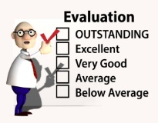
Course Assessment (Evaluation)
The grade in this course will be obtained in points. You will need 92 points or more to get an A and at least 82 to get a B. See all the details below:

Grading Policy:
Points | Grade | Grade Points
92 - 100 | A | 4.00
90.0 – 91.99 | A- | 3.67
88 – 89.99 | B+ | 3.33
82 – 87.99 | B | 3.00
80.0 – 81.99 | B- | 2.67
76.7 - 79.99 | C+ | 2.33
73.4 – 76.6 | C | 2.00
70.0 - 73.3 | C- | 1.67
66.7 - 69.9 | D+ | 1.33
63.4 - 66.6 | D | 1.00
60.0 - 63.3 | D- | 0.67
0 - 59.9 | E | 0.00
This is important!
Grades will not be rounded up. All students will have the same opportunities during the semester to improve their grades with extra credits, the "Bank time Option," and other optional assignments. In this way, any student who wants to improve their grade can take advantage of the opportunities available during the semester. More information on UF grading policy can be found at https://catalog.ufl.edu/ugrad/current/regulations/info/grades.aspx.
The course consists of various components that contribute to your grade. Each component has various assignments:

Basics of Word: 5%
Word Formatting assignment, or one of the options in the MS Word certification assignment (one of the options is completing a LinkedIn Course)

Basics of Excel: 10%
Excel Quizzes or one of the options in the MS Excel Certification assignment (one of the options is completing a LinkedIn Course)

Other Quizzes – 20%
- Intro to this Course quizzes
- Problem-Solving Process
- Statistics and Pivot Tables
- Regression

Notes about quizzes
- Quizzes can be taken at any time before the deadline.
- You can take the quizzes two times.
- For your grade calculation, the system will only use the highest grade.
- The answers to the quizzes will be published after the due date. Accordingly, you will not get individualized feedback unless your answer is right but was not taken by the system.
- No quiz points will be awarded after the deadline unless you have a valid excuse.
- Quizzes are timed.
- If you start a quiz, there is no way to stop it. Before starting a quiz, ensure you are prepared; otherwise, you will lose one of your opportunities.

General course Assignments – 35%
Assess your ability to apply the concepts and use them to analyze real-world scenarios or cases. According to previous students, the average hours spent on each module are approximately 6 to 8 hours. To fulfill the requirements, you should submit one or more files in each assignment. Assignments usually ask you to reflect, and the one in week 13 will ask you to do peer reviews.
- Reflections and self-assessments: provide opportunities to develop reflective practice.
- Peer reviews: Contribute to your critical thinking, inclusive communication, and learning of the content. It also develops the professional skill of providing feedback to peers.
Midterm assignment - 10%
In this assignment, you will use Excel and Word to create a report.
Final Assignment – 10%
Here, students will show their achievement of the course goals by presenting evidence for each through a final presentation that will be submitted twice. Students will get reviews on the first submission.


Participation – 10 %
Participating in a community of learning is relevant to your future professional practice. Accordingly, you will share your knowledge and experiences to build on the other students' understanding of course topics. This sharing will occur through discussion boards and Perusall, an artificial intelligence platform that supports discussions around readings and podcasts.
Note: You must participate in at least 4 of the six discussions and choose 2 Perusall assignments, one on module 8 and one on module 9.
These participation activities build on your analysis and critical thinking regarding the use of course content in the future. It also builds upon your inclusive communication.
This is important!
Note: This course has two types of discussion boards. [1] Participation assignment-related (graded): Students must respond to prompts related to the real-life application of the course content in these discussions.
[2] Support or assignment-related discussion boards: Students ask questions about the assignment. Students who participate in these discussions will not get participation points.

Regarding the Certification assignment (optional)
You can choose between the Word formatting assignment or one of the options in the Word Certification assignment (5%). You can also choose between the basics of Excel quizzes or one of the options in the Excel Certification (10%). In Canvas, you can find further information on these optional assignments. You will also find instructional materials to support your Exam preparation and discount vouchers you can use to get a lower exam price.

One of the options is to take the Certification in Word or Excel. If you decide to take it, you must go to a Certiport-authorized testing center and take an exam with them.
Note: I have no business relationship (or any other) with Certiport, and Certiport is not affiliated with the University of Florida. Therefore, I do not know how the certification process works with them today, nor can I reserve a spot for the exam.
Frequently Asked Questions (FAQ) about how the Certification will count in your grade:
"I already have a certification. Should I take the exam again?"
No, you do not need to take the exam again. Instead, you must upload the certification credentials to the right certification Canvas assignment. I will award you all the possible points for the course component related to your certification (Basics of Word: 5 points; Basics of Excel: 10 points).
"If I have submitted proof of the Word certification, do I need to do the Word Formatting Assignment?"
You do not need to do the Word formatting assignment (and it is not expected to do so) because you have already reached all the possible points in that course component. If you submit the certification (5 points) and the Word Formatting assignment
"If I have the Excel certification, should I also take the Basics of Excel quizzes?"
You are not supposed to take the quizzes (and it is not expected) because you have already reached all the possible points in that course component. Taking the quizzes will not give you additional points.
"What if I had a poor grade in the Word formatting assignment or one or more Excel quizzes? How would the certification help me?"
I will give you the points you need to get all the possible points in that course component with the certification. For example, if you got only 2 points in the Word Formatting Assignment, the Certification would raise your grade to 5 points in that course component. Similarly, the certification would give you five additional points if you got only 5 out of 10 possible points in the Basics of Excel Quizzes. However, if you have all the points in the quizzes and submit proof of your certification, your grade in that course component will not increase because you already have all the possible points in that course component.
If I showed proof of my certification, should I take the quizzes in the other quizzes course component?
You are expected to take all the quizzes on the "other quizzes" course component (20 points).

Time Zone considerations
In Canvas, you will find a list of the assignments with their due dates in Eastern Time. The deadlines listed are the latest you can submit the assignment (be aware that Canvas shows two dates: the due date and the date until the assignment is available for late submission – 1 day later). Install the Canvas student App and activate the notifications.
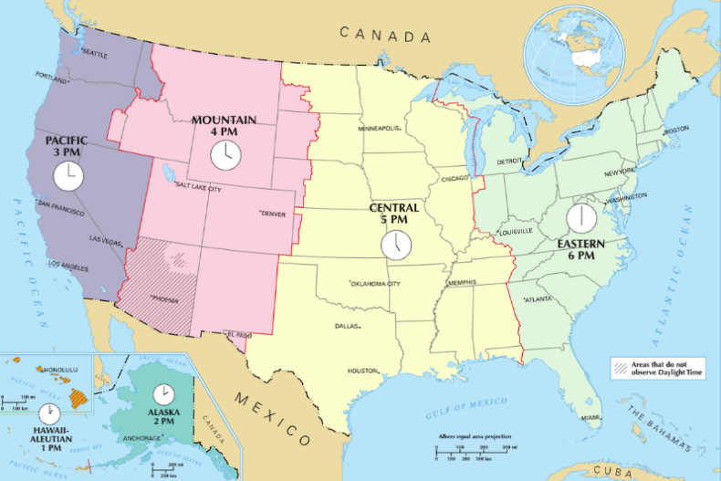
Students in a different Time zone should adjust their schedules to comply with the Eastern time requirement. For example, if you are in Los Angeles, CA, you must submit before 9 pm Pacific time.

Policies on course evaluation
This is important!
Please ensure we can grade the file you want us to grade.

These are some tips to avoid having a corrupt or the wrong file on Canvas: do not wait until the last minute to try to upload your assignments or take your quizzes (Battle Murphy's Law!), and instead:
- Make sure your file has no viruses
- Upload your document early (you can submit an assignment from day one, where these are published).
- Log out and log back in.
- Download your assignment and open it on a different computer or device or in another folder. Can you open it correctly? If you can, there is a high probability that we can, too.

On where you need to submit to get credit
We will only grade what is available in Canvas and was submitted through the assignment description section.
Deliverables will not be accepted in the comments by the Canvas email, the regular UF email, or any other online sharing media.
Likewise, if you complete the assignment several minutes or hours before the due date but miss submitting it before it, you can submit it later, but before the assignment is closed (you will have 23 hours and 59 minutes to get some credit for it). In this case, you will get a late penalty. After that time, you will not get credit for your deliverable.
We will only grade your last submission, so ensure it has the right file(s) and is complete.
For example, if you need to submit two different documents in an assignment, you must submit both files in one submission.
If you find out that one file is corrupt, the wrong one, or missing after verifying your submission, you should resubmit the two files in a second submission.
We will grade your last submission; therefore, any previous submissions will not be considered.
In addition, if your first submission was before the due date but your last submission is after the due date (within 1 second to 23:59 hours late), your deliverable will be graded according to the late policy.

Policy on discussion boards and Perusall activities
Since discussions are intended to facilitate student interaction, you will not participate in the talks once they are closed. There is no exception to this rule, as you still have the opportunity to participate in the other five discussions.
Note: You should participate in at least 4 of the six discussions published during the semester and in 2 Perusall assignments among several options (You will select one on module 08 and another on module 09).

Policy on late assignments

This is important!
I understand that sometimes life gives us unexpected situations; in those cases, getting on top of our duties is impossible. I know that students could miss one or more due dates for various reasons. I have decided to allow you to get up to 50% of the assignment points if you submit it between 1 second and 23 hours, 59 minutes, and 59 seconds hours late. When you submit late, you get a late penalty, a discount of 50% of the assignment's total possible number of points.
For example, if the assignment is worth 9 points, your discount is 4.5 (50% of 9 is 4.5 points). Accordingly, if the grade in that assignment were 7 points, the final grade, after the late penalty discount, would be 2.5: 7 - 4.5 = 2.5.
The good news is that you can use the Bank Time at the end of the semester to waive this penalty. It is up to you to become eligible.
The deliverable will not be accepted 23 hours, 59 minutes, and 59 seconds after the due date, and you will get 0 points on that assignment.
Frequent question:
Can I use Bank Time to submit an assignment and get credit for it?
Yes, but you will get the late policy discount.

Policy on late Quizzes
You can submit your quiz late up to 23 hours, 59 minutes, and 59 seconds after its deadline. However, your submission will incur a late penalty. If you missed a quiz, there is no way you can take it 24 hours after the deadline has passed unless:
- The quiz due date was the first week of classes, and you added the course that week.
- You use the Bank Time option to take the missing quiz (In this case, you will get a late penalty).

Exceptions to the late policy
Exceptions to the late policy are only allowed per university policy or if you become eligible to use the bank time option (See below for more information about the bank time option).


Policy on Extra-time or Extensions
Since this class is a 3-credit course taught in 15 weeks, students are expected to invest 9 hours per module. However, based on data shared by previous students, the module assignments can be done between 6 hours and 9 hours. Please allocate time accordingly. I do not offer extensions unless you qualify for a university-based exception (For example, you had to go to the Emergency Room, have a family emergency, etc.).
Extra time for athletes or other students in special academic programs
I’m happy to grant early access to any assignment you need. Since assignments are posted several days in advance and typically take about six hours to complete (based on feedback from previous semesters), I haven’t considered offering extra time. However, an academic advisor reminded me that athletes are aware of their competition schedules (a similar situation might be experienced by students in academic commitments). Please plan ahead and submit your work before leaving for a tournament or academic activity/competition.
If you have a special situation, email me through your UF account and copy your Academic Advisor. If your advisor approves, I’ll gladly work with you.
Extra time in assignments for Students with special needs
Please plan if you have been approved for extra time for out-of-class assignments. This course is fast paced. We do not have a specific class time; assignments are not timed and are published days before the due dates. However, I understand that you work at a different pace. Accordingly, I will not apply the late policy to your deliverable if you submit your assignment late (up to 23 hours, 59 minutes, and 59 seconds). Please remind me to waive it, as Canvas will automatically apply it. Deliverables will not be accepted after that date.
Extra time in quizzes for students with special needs
Please email me your current DRC request as soon as possible, or at least one week before the quiz deadline, to get your extra time added.

Policy on Attendance and what I expect of your weekly work.
Since this is an online course, there is no attendance requirement. However, I expect you to watch the weekly messages and course videos. I also expect you to engage in conversations with the other class students and provide constructive peer reviews through the discussion boards.
Note:
The requirements for class attendance, make-up exams, assignments, and other coursework in this course are consistent with university policies. Click here to read the university attendance policies:
https://catalog.ufl.edu/UGRD/academic-regulations/attendance-policies/.
This is important!

Policy on corrupt deliverables or other issues in which students did not submit the right file
If one or more of the following are true for the deliverable(s) you submit, you can resubmit, but any submission after the due date will be considered late; therefore, you will get the late penalty (you can waive the late penalty the last week of classes if by that time, you are eligible for the Bank Time option).
- It has a virus,
- You sent the temporary working file created by Word or Excel instead of the one with your solution. Therefore, Canvas cannot read it and interprets it as corrupt.
- The temporary file created by Word and Excel might start with the ~ symbol in its name, like:
- ~$jmendozagarcia_Word_Ass04_Report_on_Regression.docx
- If it is corrupt when clicking on the file, Word or Excel will show an error message or no error, but it does not open.
A file can become corrupted due to a computer malfunction or a network communication issue.
Typically, when a file is corrupted in Canvas, the document name begins with the tilde symbol (~).
- The file you submitted was the wrong one (e.g., submitting a draft version or the assignment template).


Policy on Grading Dispute and Procedure:
You must submit any grading disputes to the peer mentor who graded your work (different peer mentors will work on your submissions) within five business days after your assignment grade is posted. So, once your grade is posted, please review the rubric, peer mentor comments, and the solution. Follow up immediately with them if you have a legitimate grading dispute. If you still have questions regarding the grading after the regrading, please contact your instructor. Please be aware that we will re-grade the assignment in all cases, which can cause your grade to go up or down. Please submit a justification explaining why you think your assignment needs to be regraded, and state that you are aware of the possibility of getting your grade increased or decreased because of the regrading. Please be respectful and practice the course goal "Professional and Inclusive Communication."
Please do not use phrasing such as "I worked so hard on this assignment, I deserved more points!" without explaining why. In professional practice, what counts are the results of your output.


Bank Time Option
(Available only to students who have worked consistently during the semester and meet eligibility requirements)
Because unexpected situations can arise, I will waive the late policy for two deliverables during the week the last assignment is due—no questions asked.
Eligibility:
You must have submitted at least 50% of your assignments, quizzes, or participation activities (including discussions or Perusall) at least one day before the due date.
How to use this benefit:
If you are eligible and wish to use this option, send your selected or assigned peer mentor a Canvas message during the week the last mandatory assignment is due. Use the text provided below in blue and adapt it to your situation:
(Note: Extra credit assignments are not mandatory and only serve to increase your grade.)
Subject: I am using my bank time.
Note: You may send the Bank Time option email only between Monday and Friday of the week when the last mandatory assignment is due. This timing allows us to verify your eligibility. Emails received after that Friday will not be considered for Bank Time.

Body of the message:
Dear Dr. Mendoza-Garcia, since I have submitted most of my assignments, quizzes, and participated in discussions at least one day before the due date, I would like to use my bank time to waive the late penalty on the following assignment(s): [replace this text with the name of the one or two assignments].
Below is the information about my submission dates for the assignments. As you see, I submitted early [replace with the number of assignments submitted early] out of 25, which is more than 50%. I am following the student's honor code when writing this email:
Other Assignments
-simple data analysis: [use: early, on time, late, or missing]
-statistic assignment: [use: early, on time, late, or missing]
-idea generation: etc…
-decision making:
-regression analysis:
-regression report:
- Mailmerging:
-[if applicable, include other mandatory assignments not included]

Midterm Assignment
pivot tables and writing a data analysis report: [early? On time? Late? Missing?]
Final Assignment
- Probl.Solv. Part 1:
-Probl.Solv.Part 2:
-Probl.Solv.Part 3:

Discussions (include only the mandatory ones in which you finish participating early with your original thread and your two replies)…
-discussion 1: early, on time, late, missing?
-discussion 2: early, on time, late, missing?
-discussion 3: etc...
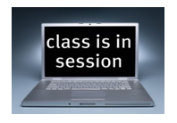
-discussion 4:
-discussion 5:

Chosen Perusall activities:
-write here the name of the activity:[early, on time, missing?]

Other Quizzes
-M01: Syllabus:
-M01: Email etiquette
-M03:The problem-solving process
-M07: Statistics
-M12: Regression Analysis

Basics of Excel:
-M03 quiz: Basics of Excel
-M03 quiz: Using Cell Ref:
-M04 quiz: Using mixed cell ref:

-OR: Excel certification assignment:

Basics of Word:
-Word formatting:
OR: Word Certification assignment:

Meeting Times/ Course Schedule:
This is an asynchronous online course with no set meeting times. All lecture videos and course materials are delivered online through Canvas, the UF course management system, LinkedIn Learning, and other online resources. Students can work ahead since lecture videos and assignments are listed well in advance of the due dates for each assignment.
Make sure you watch the weekly message as soon as it is published. Since it will be sent through an announcement, activate the Canvas notifications on your phone app.

This is important!

University Honesty Policy
UF students are bound by The Honor Pledge, which states, "We, the members of the University of Florida community, pledge to hold ourselves and our peers to the highest standards of honor and integrity by abiding by the Honor Code. On all work submitted for credit by students at the University of Florida, the following pledge is either required or implied: "On my honor, I have neither given nor received unauthorized aid in doing this assignment." The Honor Code (https://sccr.dso.ufl.edu/process/student-conduct-code/) outlines several behaviors that are in violation of this code, along with possible sanctions. Furthermore, you are obligated to report any condition that facilitates academic misconduct to appropriate personnel. If you have any questions or concerns, please consult this class's instructor or peer mentors.

My expectations of your work
Specifically for our course, I expect you to work on the assignments individually. I also hope you help each other with the discussion boards, but please refrain from providing your files or solutions to other students. I also expect you to work from scratch or use material created only by yourself. It is not approved to use deliverables from previous semesters created by you or another student in the same or previous semester. Neither are they accepted solutions that can also be found online. All these cases, or similar ones, will be considered suspicious of plagiarism and reported to the Dean of Students.

How will I know you used a deliverable previously submitted by another student?

All assignments are checked using Turnitin to ensure the originality of the composition. Therefore, your deliverable will be compared with those previously submitted in the same or other semesters.
Failure to comply with this commitment will result in disciplinary action compliant with the UF Student Honor Code. See the process at this link: Dean of Students' office.
Note: Reporting you to the Dean of Students Office is time-consuming, and I prefer to use that time to help you learn what you need to do well in the assignments. I am asking you to take your academic integrity very seriously. I understand that learning new concepts can be challenging and that you may become frustrated. However, before deciding to pursue alternative options (e.g., cheating, plagiarism), please contact one of your peer mentors or me. I will do my best (and my peer mentors) to help you learn what you need to succeed academically.

Consequences related to your grade in the course
If, after the process, you are found responsible for any violation of the student honor code, you will get a zero (0) on the assignment, and you will get no extra credits in the course. In addition, your maximum grade in the course will be a C, independent of the number of assignments for which you were found responsible for plagiarism. It could be less than a C. You will not be allowed to drop the course.
If the assignment is part of a course component, you will get a 0 in the course component. For example, the course component Basics of Excel quizzes consists of 4 quizzes, each worth 10 points. A violation of the student honor code in one or more of these quizzes will imply that you get zero (0) points in that course component, meaning that your other quiz grades in that course component would be transformed to 0. Similarly, choose to complete the Excel certification option instead of the quizzes, but you will be found responsible for violating the student honor code. You will get zero points in all the Basics of Excel course components regardless of the number of points you have in the Basics of Excel quizzes. A similar principle applies to the Basics of Word course component and its optional certification assignment.

Students requiring accommodation:
Students with disabilities who experience learning barriers and would like to request academic accommodations should contact the Disability Resource Center by visiting https://disability.ufl.edu/students/get-started/. Students must share their accommodation letter with their instructor and discuss their access needs as early as possible in the semester.

Course Resources


Materials & Supply Fees: none

Textbook:

Software required for this course.

Students must install the desktop version of the MS Office software package on their computers because the online version does not have all of the functionalities taught in the course.
While you are a UF student, you can obtain free access to the latest UF-approved Office version from the UF IT website.

You can also use UF-Apps, a service offered by the University of Florida, to run the desktop version on a virtual machine.
This is important!


Most videos and assignments are recorded using the Windows version of Office; therefore, I strongly recommend using a Windows computer for this class.
However, if you decide to use a Mac and the desktop Mac version of Office, be aware that some menus and options are in different places. However, the functionality is the same. For example, you may need extra time to determine where these options are located. We will be happy to help you during office hours or through discussion boards, but it will still take you more time than if you work in the Windows version of the software.

Required computer
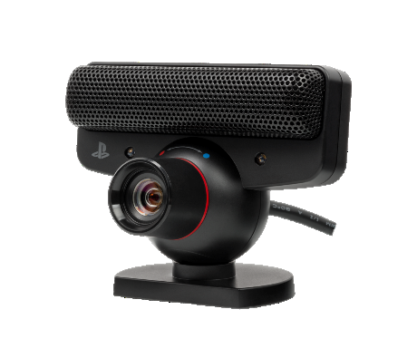
For this course, your computer should meet or exceed the University of Florida Student Computing Recommendations and the Warrington Laptop Computer requirements


Internet connection
CGS2531 is an online course. To succeed in this course, you will need a reliable high-speed internet connection. Low-speed connections may cause delays in videos or other issues with online content. Internet connections in hotels or public places are usually slow.
This Photo by Unknown Author
is licensed under CC BY-SA

Technical issues
If you experience technical difficulties, please contact the help desk. Peer mentors or the instructor are not authorized to provide guidance on this matter.

Academic Policies & Resources
Please find these policies here: https://go.ufl.edu/syllabuspolicies. My courses accommodate these policies.

Commitment to a Positive Learning Environment
The Herbert Wertheim College of Engineering values varied perspectives and lived experiences within our community and is committed to supporting the University’s core values.
If you feel like your performance in class is being impacted, please contact your instructor or any of the following:
• Your academic advisor or Undergraduate Coordinator
• HWCOE Human Resources, 352-392-0904, student-support-hr@eng.ufl.edu
• Pam Dickrell, Associate Dean of Student Affairs, 352-392-2177, pld@ufl.edu

