Engineering Faculty Council Agenda 1/13/2022

Engineering Faculty Council Meeting Minutes

01/13/2022

Meeting Link: https://ufl.zoom.us/j/99979401995?pwd=U2xZUHVrdTFNcXZWcVVYMFcyMVBVUT09
Meeting ID: 999 7940 1995
Passcode: 789377

Attendance: Keith Rambo, Katherine Deliz, Wesley Bolch, Natalie Wall, Lee Murfee, Amelia Dempere, Juan C. Nino, Mike Fang, Denis Hiltunen, J. Peters, Jeremiah Blanchard, Katie B., Lisa Anthony, Jennifer Nappo (HR guest speaker)
- Meeting Called to Order 2:41
- Approve the December 9, 2021 EFC meeting minutes 2:40-2:45
  - Meeting Minutes approved by unanimous consent without any changes.
- EFC Meeting Dates (Zoom 3- 4 p.m.):
EFC Meeting Dates | Senate Meeting Dates
11/04/21 | 11/18/21
12/09/21 | 12/16/21
01/13/22 | 01/20/22
02/10/22 | 02/17/22
03/10/22 | 03/17/22
04/07/22 | 04/14/22
05/12/22 | 05/05/22

- EFC Chair Message 2:45-2:48
Keith: Infrastructure council did reach a resolution and will write a report. Decided to slow down and consider other options, and will use external and internal feedback to select best alternatives.

- Jennifer Nappo Director HR (directly reports to the college of Engineering) – “HR support for Faculty with concerns/problems” 2:48-2.58
  - Navigating the HR process: Discussed slides with information on staff and roles icluding
    - Jen Nappo – new director, came from SHANDS
    - Donna Stilwell – job openings etc.
    - Paynie – all immigration paperwork required to work at UF, appointment letters and graduate student recruitment – list per each department (see slides)
    - Kelly Gentry – payments, pay leave, compliance, back up for immigration
    - Sonya Brooks – HR reports and post positions
    - HR offers 1x1 virtual office hours.
  - How to address concerned raised by JCN in email to Keith (and previously discussed during EFC meetings) to clarify: “ … if you have x problem, go here… if your issue is about Y go there… if your problem has not been resolved, go there… if you don’t feel comfortable talking withing Engineering HR do this etc.”?
  - For misconduct reports:
    - Go directly to Jennifer Nappo (jpennacc@ufl.edu)
    - Can also go directly to employee’s relationship – Holly Hanna (hjhanna3@ufl.edu)
  - Jennifer said she will provide a flowchart/infographic of the different staff and their roles
  - Regardless of the chain of command Jennifer is open to be the 1st point of contact and reach out to other UF support when needed…eg. Title 9

- Committee Updates: 3:58-3:24
  - Cammy was grateful and sent a message about the effort put forward by all faculty and staff
  - Curricular Items discussed under Education Committee.
  - Education Committee: (Wes)
    - Jorg : initiated discussion about EGN 5XXX.
    - Discussion on course:
      - This is a general introductory course for grad students but can be an advanced course for Undergrad students
      - Has been put forward for the new MS in Artificial Intelligence – will be be one of the core courses with a focus on applied Machine Learning.
        - Concerned about how applied the course was – there is an understanding that projects described on syllabus must be hands on for his to be an applied class.
    - Jeremiah – students don’t need to be tied to a specific department to take the course. Open to all engineers
    - Suggested change of title from “Machine Learning for AI Systems” to Fundamentals of Applied Machine Learning
  - Budget Committee: (Natalie, Jorg)
    - Jorg was on budget meeting – joined EFC meeting a bit late
    - Now have some budget information on the website - new entries showing current input and output monetarily

  - Faculty Welfare Committee: (Lisa, Subrata)
    - Lisa: have not met yet.

  - IDEA: (Katie, Amelia)
    - Katie: committee have not met yet.
    - Event tomorrow - Guest Lecture by Courtney Taylor in the institute of Black Culture. Provided PDF of additional activities for MLK

  - Scholarship: (Michael)
    - Nothing to report

- IDEA Discussion 3:24-3:24
  - Nothing to report
- Old Business 3:24-3:26
  - Keith shared resolution letter and recommended to include UF researchers in different departments to get involved.

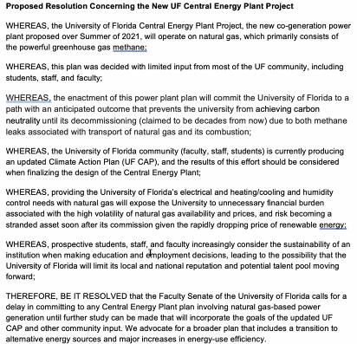
- New Business 3:26- 3:26
  - Nothing to report
- Adjourn 3:27

