Engineering Faculty Council Meeting Minutes
March 18th, 2021
https://ufl.zoom.us/j/94287410022?pwd=NFp5cGFsWmlBOVBWUUdiK0tCaG9zQT09
Meeting ID: 942 8741 0022
Password: 470144

12 Participants in Attendance: Katherine Deliz, Keith Rambo, Juan Nino, Toshi Nishida, Michael Fang, Wesley Bolch, Lawrence Ukeiley, Jeremiah Blanchard, Dennis Hiltunen, J. Peters, Lee Murfee, Peng Jiang

Start Time: 3:05
- After brief discussion on COVID Vaccination

- Approve the February 11, 2021 EFC meeting minutes - Approved
- EFC Chair Message –
- McCarty Woods was labeled a future building site by the 2020-30 Campus Master Plan; but faculty fought to remove it from development plans.
- Chair election coming up soon
  - 5 EFC spots open and 8 candidates
    - No MAE representative – and Lawrence will be off this coming year
- Potential increase in Pell scholarships for UG

- Committee Updates:

  - Education Committee: No updates
(Pam, Dennis, Wes)

- Teaching Via Zoom
- All curricular items were approved- all of these courses have been offered.

  - Survey Committee
(Pending Deletion)

  - Budget Committee (Lee): No update
    - J Peters shared in chat: end of January the governor proposed a 3.7% increase of the budget over last year -- but legislature needs to decide

  - Faculty Development Committee (Elif,Toshi, Pam):

    - Working titles for lecturers – start discussing last year but was interrupted by the pandemic. The provost is now OK to change working titles (Not HR titles – that will take more time). Expect to finalize working titles no later than July 1st.
      - Instructional Assistant, Associate Professor – this is only for Engineering Education, but can serve as model for other departments.
      - Some teaching faculty do not like the lecturer title (feel disrespected) so it’s been difficult to hire.
      - Faculty agree these titles better represent their effort, and feel others are more responsive towards them when using the Instructional Professor title instead of lecturer
      - This titles does not imply tenure
    - Question for Toshi (from JPeters): since UF is gearing up for opening up, the constraints for (planning) travel seem to be frozen in place. Particularly, can you tell us about Airbnb etc?
      - In summer B everything resumes to normal including travel
      - JP concerned it will not be able to plan for travel and purchase tickets for conferences – Toshi expects people should be able to plan for travels that will happen after July 1st
        - Can we book under the same rules that were beforehand (without special authorization from the dean)?
          - Action Item: Toshi will follow up

  - IT Committee (Juan): no new updates... just moving along with old business. Posting more guidelines for faculty to do high flex…more hands on videos etc.

  - Research and Scholarly Activities
(Michael and Keith)
- Keith is working with Hans group on promotion and tenure – there is a focus on international and URM faculty and the impact of student evaluations in tenure advancement. Statement below:
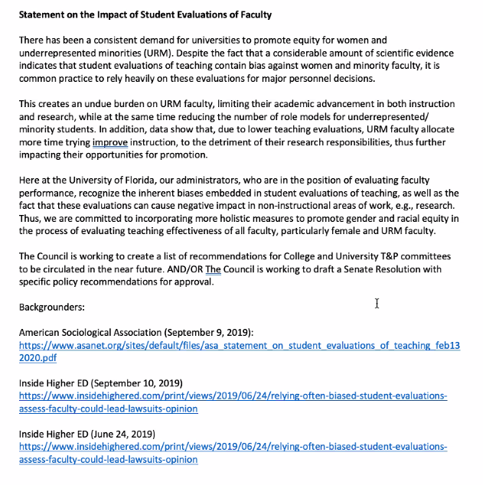
- There are concerns about URM progress and evaluation, due to perception and implicit biased toward certain groups.
- Development of presentation and other resources to foster peer mentoring
  - Peer mentoring is more of a culture in each research group
- McCormik described the framework for a successful mentoring program in the scientific environment - targeted to students.
- It was proposed that all of us at the EFC use department faculty meetings to inform/remind that we are the representative at the EFC, and that we can take concerns to the EFC to make change.
Action Item: Keith and Mike will come up with a message for approval to be distributed by all EFC members to their departments.

- IDEA discussion
(Larry and Toshi): College is working on a climate survey about how equity and diversity is perceived.

- Old Business

- Working Titles (discussed earlier in Toshi Update)
- Constitution Revision: roughly half way through the constitution – only 2 more meetings before the end of the year (with Tylor Rose attorney). New document will be completed by the end of the 2021 year, and will be reviewed on Spring 2022.
- House and Senate are passing a state legislature that will allow students to record and use the class material. Chair of faculty senate to have a meeting to reach a resolution– We will have to vote if we oppose this legislature.

- New Business

- Adjourn: 3:51PM

Meeting minutes by: Katherine Deliz

