Meeting Attendees
Unit | Representative(s)
EED | John Mendoza
ISE | McKenzie Landrum, Murwan Siddig, Mengyu Li
ABE | Daniel Lee
BME | Mingzhou Ding
CHE | Helena Weaver
ECE
CISE | Cheryl Resch
ESSIE | Amelia Dempere
MAE | Norman Fitz-Coy
MSE | Megan Butala
Dean’s Office | Malisa Sarntinoranont, Warren Dixon
Other Guest | Sarah Lynne

- Call to Order (McKenzie Landrum) 16:03
Motion and second to approve August and September minutes

- Warren Dixon 16:04
Met with president. The president wanted to learn about the college, and it became clear that the BOT and president’s goal is for UF to be a top 5 engineering school. Will require more faculty and staff, may require more space. It would require an infusion of funds. Looking at industry recruitment score and peer evaluation score and increasing these since it may not require more funds.

Dr. Dixon discussed and answered questions about the “neutral leadership” culture that the new president is advocating.

- Information on PTR – Amelia Dempere 16:28
Amelia shared summary overview of PTR for university. McKenzie asked Malisa for similar data for HWCOE for November meeting.

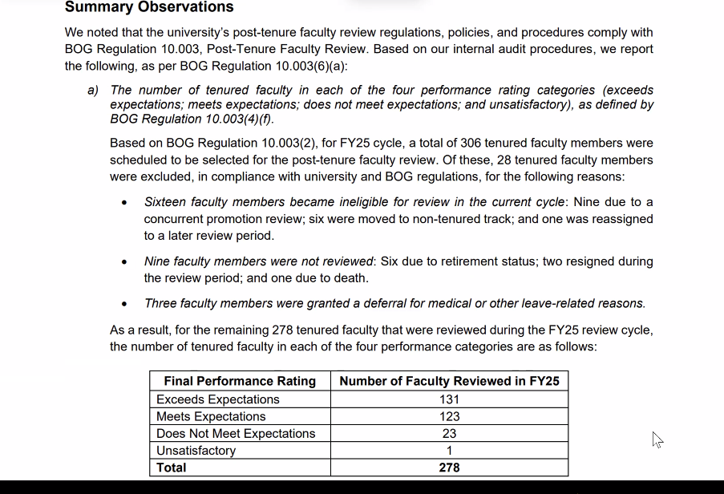

- Academic Strategic Plan – Sarah Lynne 16:35
There is a chatbot for strategic planning. Email communication will come out 10 October with links to landing page and opportunity to engage. Participants’ identity cannot be tied to their responses. There is a random de-identified ID associated with the responses. The responses are considered public records.

- Curriculum Items 16:49
- Closing CISE DAS MS program – motion and second, passed unanimously
- HSC 4063 add to AI certificate – motion and second, passed unanimously
- Committee Updates 16:54

There were no committee updates but the committee representatives were updated
- Committee on Committees (Cheryl) –
- General Education Committee () –
- Budget Committee (May) -
- Faculty Welfare (Cheryl) – syllabi will be required 45 days in advance and there will be a new tool for instructors to use
- Academic Freedom, Tenure, Professional Relations & Standards Committee () –
- Research & Scholarship () –
- Academic Assessment (Cheryl) – UF is pursuing Higher Learning Commission as new accreditor
- Steering & Council Committees (Jeremiah) –
Council Committees (McKenzie) -

- Constitution Updates 16:56

Tabled for extra meeting that will be held.

Meeting closed at 16:59

