Request for Use of UF Research & Engineering Education Facilities (REEF)

Please email space utilization requests to reef@eng.ufl.edu

Use of University of Florida Research Engineering & Education Facility (UF REEF) is limited to those activities that are directly related to the REEF’s education and research mission. All activities will be on a non-interference basis with normal REEF activities. No classified meetings are allowed at UF REEF. Export controlled or CUI meetings require prior approval.

The facility doors are open at 7:45AM Room Use: 8:00AM - 4:30PM (Monday-Friday)

The request should include:

- Name of organization:
- Meeting Title:
- Short Summary/Description:
- Point of Contact Info:
  - Name:
  - Telephone number:
  - Email address:
- Date of Event:
- Time of Event:
- Anticipated number of attendees:
- Type of room requested: (auditorium, conference room, classroom, etc.)
- Will export controlled or CUI prior approval be needed:
- Audio-Visual, computer, or network requirements:
- Any special requirements or considerations:
- Provide following information to login all attendees:
  - Name:
  - Organization:
  - Email address:

Additional Guidelines:

- Do not hang items on walls (e.g., no tape, thumb tacks, nails, poster putty)
- There is no UF REEF labor to arrange furniture or equipment
- Replace furniture and equipment in original layout or location
- Clean up. Remove debris or other items left behind
- Organizations may provide refreshments as desired, but no food or drinks (except water) are allowed in the Auditorium.

UF IS A NON-SMOKING, TOBACCO/VAPOR FREE CAMPUS

UNIVERSITY OF FLORIDA
GENERAL RELEASE OF LIABILITY, WAIVER OF CLAIMS, EXPRESS ASSUMPTION OF RISKS, AND HOLD HARMLESS AGREEMENT

Requestor: _______________________________________________

The above named Requestor shall be responsible for any loss or damage to UF property in or about the UF REEF auditorium or conference room used in the EVENT or about the EVENT by persons associated with the EVENT. Requestor will reimburse the University of Florida for any loss or damage to UF REEF property in the EVENT or about the EVENT at the fair market value of the property on the day the damage occurs.

Personal Property
- UF REEF shall not be responsible for any loss or damage to personal property placed in or about the REEF auditorium or REEF conference room belonging to Requestor or its guests, or invitees, and Requestor shall hold the University of Florida Board of Trustees and UF REEF harmless from all claims arising out of loss or damage to such property.

- Requestor shall remove from the REEF auditorium or REEF conference room, immediately upon termination of the
Event, all property belonging to Requestor and all property brought in or about the EVENT by persons associated with the EVENT in the use and occupancy of the UF REEF auditorium or conference room. If Requestor fails to remove all such property, UF REEF shall have the right to remove, store or dispose of such property at Requestor expense. UF REEF shall not be liable for any damage or loss to said property regardless of how and where same shall occur or caused by whom.

Indemnification
Requestor shall protect, maintain, save and hold harmless the State of Florida, the Florida Board of Governors, the University of Florida Board of Trustees and UF REEF, their officers, agents, servants and employees from and against any and all claims, demands, expense and liabilities arising out of injury or death to any person, or the damage, loss or destruction of any property which may occur in or about the Event (including any portion thereof which Requestor has not been given the right to occupy or use pursuant to the terms of this Agreement) or which may arise or in any way grow out of any act or omission of Requestor, its agents, subcontractors, servants, employees, invitees and occupancy of the UF REEF.

Fire and Police Department Rules and Regulations
Any organization or persons utilizing the UF REEF auditorium or conference room must agree to comply with all appropriate state and federal laws, University rules, regulations and guidelines and fire and police department rules and regulations. In addition, the organization shall agree to use and occupy the premises for no purpose which is considered indecent under the law.

In signing this agreement, I acknowledge and represent that I have read and understand it; fully intending to be bound by the same.

Requestor:

Name (Printed)

Signature DATE: ___________________

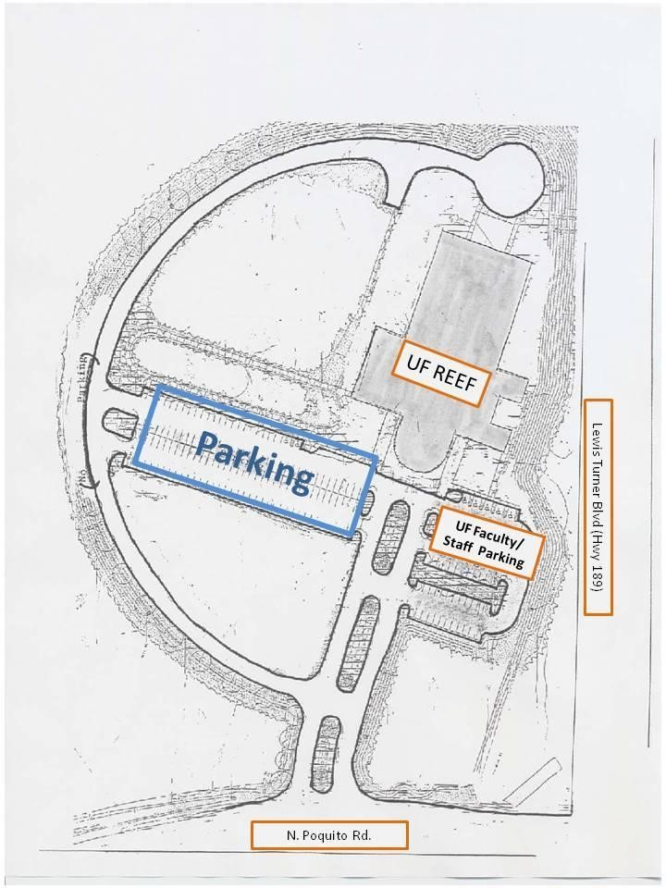
UF REEF
1350 N. Poquito Road
Shalimar, FL 32579

