Request for Use of UF Research & Engineering Education Facilities (REEF)

Please email space utilization requests to reef@eng.ufl.edu

Use of University of Florida Research Engineering & Education Facility (UF REEF) is limited to those activities that are directly related to the REEF’s education and research mission. All activities will be on a non-interference basis with normal REEF activities. No classified meetings are allowed at UF REEF. Export controlled or CUI meetings require prior approval.

The facility doors are open at 7:45AM Room Use: 8:00AM - 4:30PM (Monday-Friday)

The request should include:

- Name of organization:
- Meeting Title:
- Short Summary/Description:
- Point of Contact Info:
  - Name:
  - Telephone number:
  - Email address:
- Date of Event:
- Time of Event:
- Anticipated number of attendees:
- Type of room requested: (auditorium, conference room, classroom, etc.)
- Will export controlled or CUI prior approval be needed:
- Audio-Visual, computer, or network requirements:
- Any special requirements or considerations:
- Provide following information to login all attendees:
  - Name:
  - Organization:
  - Email address:

Additional Guidelines:

- Do not hang items on walls (e.g., no tape, thumb tacks, nails, poster putty)
- There is no UF REEF labor to arrange furniture or equipment
- Replace furniture and equipment in original layout or location
- Clean up. Remove debris or other items left behind
- Organizations may provide refreshments as desired, but no food or drinks (except water) are allowed in the Auditorium.

UF IS A NON-SMOKING, TOBACCO/VAPOR FREE CAMPUS

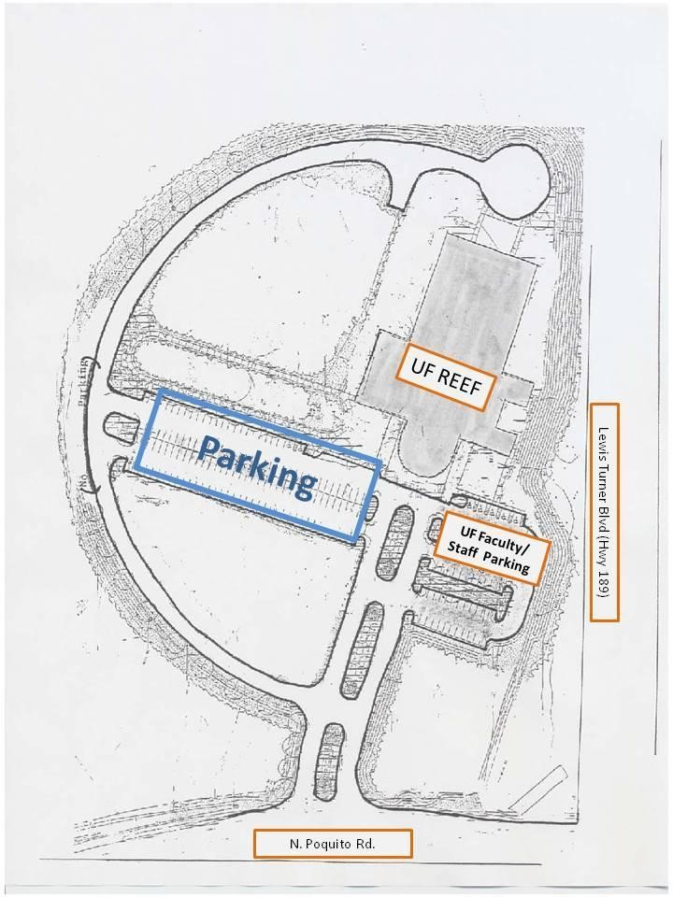
UF REEF
1350 N. Poquito Road
Shalimar, FL 32579

